FINAL EXAMINATION
TIME ALLOWED: 90’
Subject: Linear Algebra.
No books allowed.

- Compute, using de Moivre’s formula 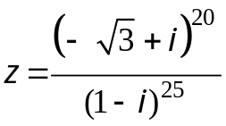
- Solve the system of equation AX = b, where
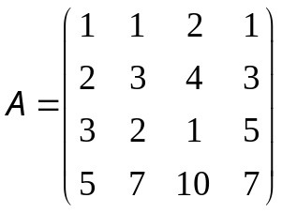, 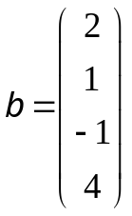,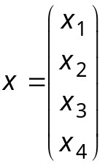

- Let 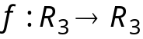 be a linear transformation.
Assume that
    - Find 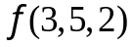.
    - Find the basis and dimension of Kerf.

- Let be a linear transformation, whose the matrix with respect to the basis 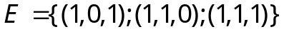 is 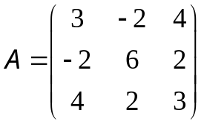
a) Find all eigenvalues and eigenvectors of 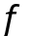.
b) Diagonalize (if possible).

Make a change of variables that transforms the quadratic form

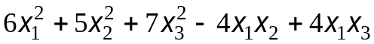 into a canonic form.

- In the xy-plane, a curve C is given by an equation 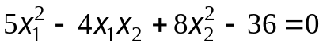.
Sketch the graph of C.

-----------------------  -----------------------

